GUÍA EVALUADA DE RESUMEN UNIDAD 0
Guía n° 1 English Language

Nombre: |  |  |  | Curso: | Iª | Fecha
Puntaje Evaluación |  |  | Puntaje de corte (60%):
Puntaje obtenido: |  |  | Calificación:

INSTRUCCIONES:
- La guía puede ser resuelta con apoyo de un diccionario y sus cuadernos de ser necesario. No está permitido copiar trabajos de otros compañeros/as.
- La guía debe ser enviada a más tardar el día martes 24 de Marzo vía mail a francisca.ipinza@elar.cl
- En ese correo puedes realizar las preguntas necesarias para realizar tu trabajo.

Objetivos: Reforzar y practicar contenidos de la unidad 0
Contenidos: Pasado Simple, Adjetivos en grado comparativo y superlativo

ITEM I.- Explanation about what are “ Past simple”, “Can – Can’t” modal verb and how to use them.

Past Simple

Subject |  |  | Past Simple (Positive) | Past Simple (Negative) | Complement
I  (Me) |  |  | Was  Worked | Was not -> wasn’t  Did not work -> didn’t work | Happy yesterday  At school
He  (Carlos) | She  (Carla) | It  (Firulais/ Chair) | Was  Came  Worked | Was not -> wasn’t  Did not -> didn’t come  Did not -> didn’t work | At Elar  Chilean
You   | We  (I and friends) | They  (my friends) | Were  Studied  Came | Were not -> weren’t  Did not -> didn’t study  Did not ->didn’t come | Student  At school by COVID19

We can classify the verbs in past into Regular and Irregular verbs
Regular Verbs

To form the past tense of regular verbs we add “ED” at the end.

Examples:
Want Wanted

INFINITIVE | PAST | MEANING
Want | Wanted | Querer
Start | Started | Comenzar
Arrive | Arrived | Llegar
Form | Formed | Formar
Appear | Appeared | Aparecer
Listen | Listened | Escuchar
Move | Moved | Cambiarse
Like | Liked | Gustar
Love | Loved | Amar
Decide | Decided | Decidir
Irregular Verbs

INFINITIVE | PAST | MEANING | INFINITIVE | PAST | MEANING
To be | Was / were | Ser o estar | Have | Had | Tener
Break | Broke | Romper | Know | Knew | Saber
Bite | Bit | Morder | Leave | Left | Abandonar
Buy | Bought | Comprar | Make | Made | Hacer
Bring | Brought | Traer | Take | Took | Tomar
Come | Came | Venir | Meet | Met | Conocer
Do | Did | Hacer | Read | Red | Leer
Drive | Drove | Manejar | Lose | Lost | Perder
Eat | Ate | Comer | Say | Said | Decir
Feel | Felt | Sentir | Sit | Sat | Sentarse
Forget | Forgot | Olvidar | Sleep | Slept | Dormir
Get | Got | Obtener | Steal | Stole | Robar
Give | Gave | Dar | Write | Wrote | Escribir
Go | Went | Ir | Think | Thought | pensar
 |  |  | Swim | Swam | Nadar
 |  |  | Tell | Told | Contar (historia)

These verbs DO NOT HAVE any rule. They have to be learn by heart.
(de memoria)
Examples:

GowentReadread
TaketookKnowknew
MeetmetWritewrote

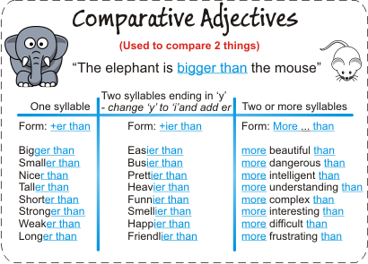
Comparative and Superlatives Adjectives
Comparative Adjectives

We use the comparative to form a comparison between two people, places, things, etc. The comparative adjective form is determined by the number of syllables in the adjective. After the comparative form, we use than before the person, place, or thing you are comparing.
Example: Russia is larger than Canada. (large)
There are three types of adjectives at comparative degree:
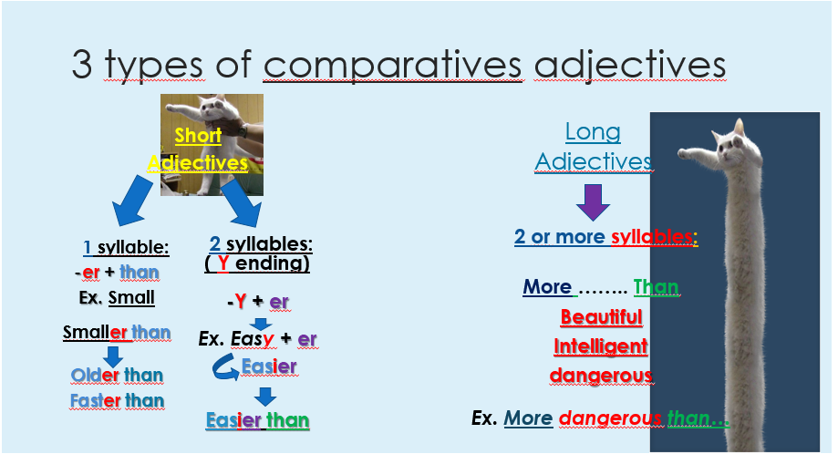

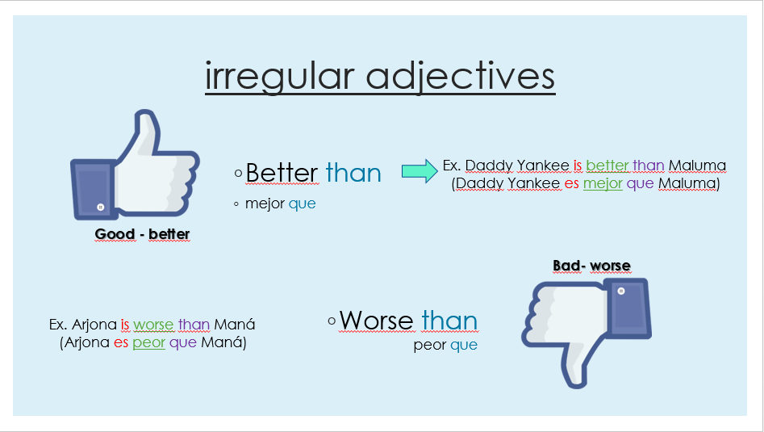

Superlative Adjectives
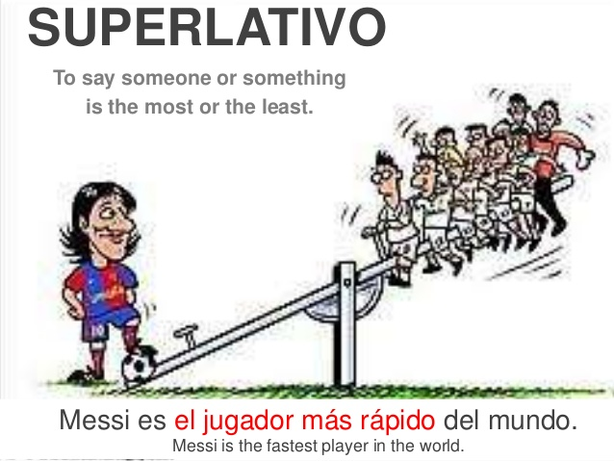
We use the superlative adjectives to say that something is the maximum on its category
Example: Rome is the most beautiful city in the world.

There are three ways of recognizing the “form” of a superlative adjective.
Short Adjectives: we add –est
Example:
old: oldest
Long adjectives: we add most.
Example:
beautiful: most beautiful
Irregular adjectives
Example:
bad: worst
good: best

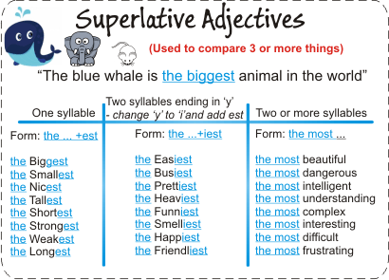

ITEM II.- Examples

Past simple -> Irregular Verbs

My father wins the lottery last year. My father Won the lottery last year
I write a letter yesterday. I Wrote a letter yesterday
My sister take photos in her trip. My sister Took photos in her trip
They give me a gift for my birthday. They Gave me a gift for my birthday

Past simple -> Regular Verbs

I want hamburgers for dinner I wanted hamburgers for dinner
The cat moves its toy The cat moved its toy
She arrive late She Arrived late

Videos: Simple Past
https://www.youtube.com/watch?v=moYDA4jbPy4
Diferencia entre was/were, did
https://www.youtube.com/watch?v=MWlnjnXr1Js

Comparatives and Superlatives adjectives

Comparatives Adjectives

The right way of writing a comparative sentence is the following.

( Subject + verb + adjective + than + complement)
Ana is taller than Michael
Ana is more beautiful than Carol
Bad bunny is better / worse than Maluma

Superlatives Adjectives

(Subject + verb + the + adjective + complement)
Atacama is the hottest place of Chile
Viña del mar is the most beautiful place of Chile
Santiago is the best/the worst place of Chile
Leo and scorpion are the angriest zodiac sign
Videos:

https://www.youtube.com/watch?v=KdGbGhp6UwA

ITEM III – Exercises
Past Simple
a) Complete using the past of the verbs in (brackets) (1 pt)
The young singer Lady Gaga ___was_ (be) born in New York city in March 20th, 1986. At the age of 15 she ___________ (move) to Los Angeles where she ______________ (decide) to start to sing. She _____________ (tell) her parents that she _____________ (want) to be a singer because she _____________ (feel) she could be a good artist. Some years later she _______________ (come) back to New York where she ____________ (go) to the same school of Paris Hilton. She ______________ (have) a lot of talent, and in 2008 she ________________ (record) her first album. Now, she is very famous and recognized.

b) Change the verb into past (1 pt)

- My mother _________________________ (DECIDE) to buy a new car.
- I _________________________ (WANT) to travel abroad.
- My brother ___________________________ (record) a very funny video.
- The party _______________________ (START) at 10 o’clock.
- My sister ____________________________ (ARRIVE) with a friend.
- I ______________________________ (MOVE) to my new apartment last week.
- My friends ___________________________ (LIKE) the movie we watched yesterday.

c) Write the verb in present and past under the picture. (1 pt)
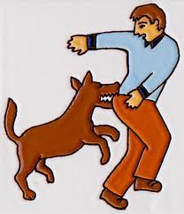
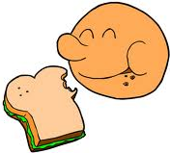
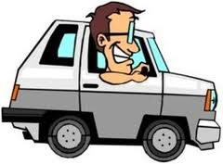


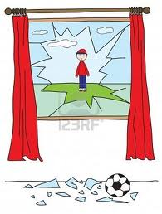
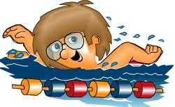



d) Unscramble the words and write the verbs where correspond (1 pt)
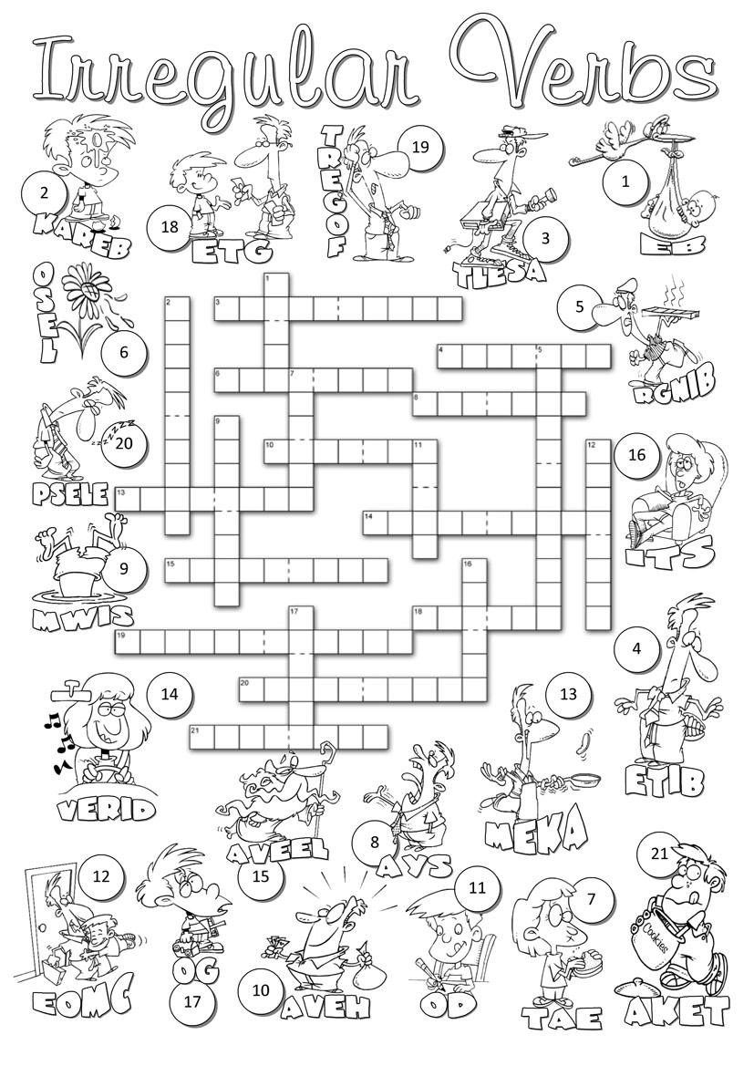

Comparatives and Superlative Adjectives

f) Use comparatives adjectives (1 pt)

- Europe is_____________________________ than South America. (small)
- The Amazon river is__________________________ than the Mississipi river. (long)
- Antartica is________________________________than Africa. (cold)
- French is_________________________________________ than English. (difficult)
- New York is______________________________ than Seattle. (exciting)
- London is ______________________________ than Madrid. (expensive)
- Italy is________________________________than France. (cheap)
- Spanish is_________________________________than English language.(difficult)
- Chile is_________________________________than Brazil. (beautiful)
10. Italian is________________________than Spanish. (easy).

g) Use Superlatives Adjectives (1 pt)
Use the following words and apply superlatives adjectives. Use a dictionary if you need.
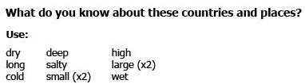

Ex: The Western Deep Gold Mine is the deepest mine in the world.
- The Pacific Ocean is _______________________ ocean in the world.
- Asia is __________________________________ continent in the world.
- Mount Everest is ______________________ mountain in the world.

- The Atacama Desert is ________________________ desert in the world.
- Columbia is _______________________ country in the world.
- Oceania is __________________________ continent in the world.
- The Nile is _________________________ river in the world.
- Antartica is ____________________ continent in the world.
- The Vatican City is _________________________ country in the world.
- The Dead Sea is _________________________ sea in the world.

h) Fill in the spaces below with the comparative or superlative form of the word under the line.
The United States of America
- The United States is a big country, but is not the ______________________ (big) country in the world.
- Russia, Canada, and China are __________________ (big) than the United States. USA has fifty states.
- Alaska is the ____________________(large) state and Rhode Island is the __________________ (small) state.
- Rhode Island is ____________(industrial) and has a ____________(great) population than Alaska.
- Massachusetts and Virginia are the _________(old) states. Hawaii and Alaska are the__________ (new) states.
- The United States has many great cities. New York City is the _____________________(big) city. Los Angeles is the second ________________________(big) city and Chicago is the third.
- Some people believe that San Francisco is the ________________________________(beautiful) in the country.
- Other people say that Seattle is the _____________________(clean), ____________________ (safe) and _________________________ (good) city to live in.
- The weather is not the same everywhere in the country. The North is generally ___________________(cold) than the South, and the West is usually ___________________________ (dry) than the East.
